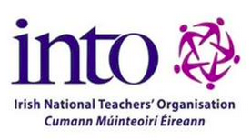
TEACHMEET IRELAND - ‘INTO Education Consultative Conference 2016’
PRESENTERS FORM
Thank you for offering to present at our INTO Education Conference Teachmeet
in Tullamore on Saturday November 19th, 2016!
Please complete the following form for our information, submitting the completed form to teachmeetireland@gmail.com.
Information will form a bibliography of presenters which will be shared on the day.

Name: __________________________ Email: __________________________
Twitter name (if applicable): _____________________
School name and address:
________________________________________________________

Type of Presentation: Nano (2 mins) Macro (7 mins)
Brief Synopsis of Presentation (for purpose of meeting handout)
(Less than 50 words please!)
_____________________________________________________________________________________________________________________________________________________________________________________________________________________________________________
Tell us a bit about yourself, in 50 words or so:
_____________________________________________________________________________________________________________________________________________________________________________________________________________________________________________
Do you give permission for your slides to be shared on our website after for all interested parties? Yes No

Please note: Should there be an oversubscription of presentations, unfortunately a lottery system will be used to choose speakers.
Please email completed forms to teachmeetireland@gmail.com.
Thank you for your interest!

